**Creating a story**

It can also be interesting to ask learners to create a story about a graph or chart that has no labels on the axes. A graph or chart that is to be used as part of a question in an exercise problem could first be shown with its labels removed. This will make learners examine the graph carefully and think about the significance of each of its parts.

For example:

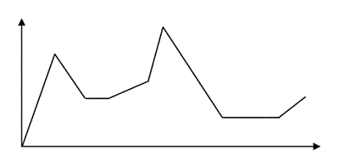

or

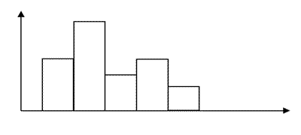

**Adapting to other contexts**

Similar graphs and charts could be used in learners’ own contexts to challenge them to think about their possible meaning in that context.

For example, the chart might represent sales of certain items in a retail setting, or the types of treatments requested in a beauty therapy salon. Charts and graphs are regularly used in many other curriculum areas, for example, history, geography, physical education and science. Learners could be asked to interpret the graph or chart in the context of one of their other curriculum subjects.